Department of Computing

EE433: Digital Image Processing
Class: BSCS 6

Lab 9: Spatial Filter Basics
CLO4: Design and implement algorithms for digital image processing operations such as histogram equalization, enhancement and restoration, filtering, and de-noising

Instructor: Dr Khawar Khursheed

Lab 9: Spatial Filter Basics
Name: Ahmad Amjad Mughal
Reg No: 121672
Class: BSCS6C
Lab Tasks
Task #1: Effect of averaging and the size of averaging filters
Code
#Necessary Libraries
import numpy as np
from PIL import Image

#Get Image as input and convert it into array
image_input = Image.open('smoothing.tif')
imageArray = np.asarray(image_input)
#Pad the window of image with constant value
image_padding = np.pad(imageArray, (3, 3), 'constant')

#Mask of variable size having each pixel's value 1
initialize = np.ones((7, 7))
#Updated Pixel's value after divided by size
initialize = initialize/49
smooth = np.zeros(imageArray.shape, dtype = np.uint8)
#Traversing through each pixel and calculate average
for row in range(len(image_padding)-6):
for col in range(len(image_padding[0])-6):
avg = 0
for r in range(len(initialize)):
for c in range(len(initialize[0])):
##Multiplying each pixels with average value
avg+= initialize[r][c]*image_padding[row+r][col+c]
smooth[row][col]= avg
#Convert ImageArray to Image Object
smoothimage=Image.fromarray(smooth)
smoothimage.show()

Original Image

3*3 Image After Average Filter

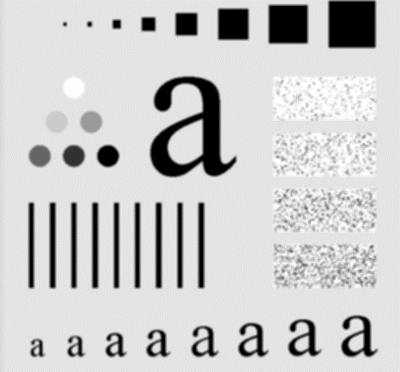

Weighted Average Filter

Code
#Necessary Libraries
import numpy as np
from PIL import Image

#Get Image as input and convert it into array
image = Image.open('smoothing.tif')
imageArray = np.asarray(image)
#Pad the window of image with constant value
image_padding = np.pad(imageArray, (3, 3), 'constant')

#Mask of variable size having each pixel's hardcoded
initialize = np.array([ [1, 1, 2, 1, 1]
,[1, 2, 4, 2, 1]
,[2, 4, 8, 4, 2]
,[1, 2, 4, 2, 1]
,[1, 1, 2, 1, 1]

],np.float64)
#Updated Pixel's value after divided by size
initialize = initialize/52
smooth = np.zeros(imageArray.shape, dtype = np.uint8)
#Traversing through each pixel and calculate average
for row in range(len(image_padding)-6):
for col in range(len(image_padding[0])-6):
avg = 0
for r in range(len(initialize)):
for c in range(len(initialize[0])):
#Multiplying each pixels with average value
avg+= initialize[r][c]*image_padding[row+r][col+c]
smooth[row][col]= avg
#Convert ImageArray to Image Object
smoothimage=Image.fromarray(smooth)
smoothimage.show()

Screenshot

By Using 5*5 AverageFilter

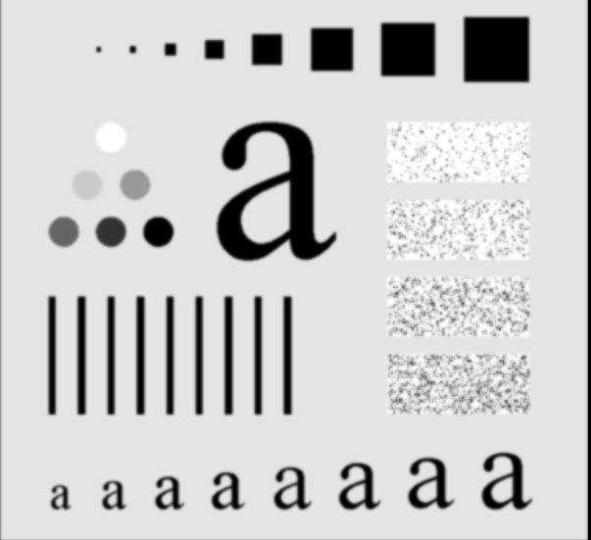

What do you observe when increasing the size of the filter and why?
Ans. As we increased the size of the filter, the resulting picture shows blurriness. So greater the size of mask, smoother the picture we get.

Task #2: Gaussian smoothing
Code
#Include Necessary libraries
import cv2
import matplotlib.pyplot as plt
import matplotlib.image as mpimg
import numpy as np
from PIL import Image
#Open an image and convert it into Grey Scale Image
image = Image.open("smoothing.tif").convert('L') #open image
width,height = image.size
#Perform padding on half pixels
filter_size = 3
padding = (filter_size-1)/2
#counter that counts number of pixels checked
Iteration_Counter = 0;
Filter=[[1,1,2,2,2,1,1],
[1,2,2,4,2,2,1],
[2,2,4,8,4,2,2],
[2,4,8,16,8,4,2],
[2,2,4,8,4,2,2],
[1,2,2,4,2,2,1],
[1,1,2,2,2,1,1] ]
Counter=0
image_array = np.array(image)
#padd pixels with constant value
image_array = np.pad(image_array,3,'constant')
new_img = np.pad(image_array,1,'constant')
#Traverse through each pixel and multiply original pixel with filter pixel values to get updated pixel at that location
for i in range(0,width):
for j in range(0,height):
for k in range(0,(filter_size)):
for l in range(0,(filter_size)):
Iteration_Counter += image_array[i+k][j+l]*Filter[k][l]
#Dividing by total number of pixels
Iteration_Counter=Iteration_Counter/7
new_img[i][j]=Iteration_Counter;
Iteration_Counter=0
print (new_img)
final_image = Image.fromarray(new_img)
final_image.save("smoothingGaussian.jpg")
Screenshot
Original Image

Output Image
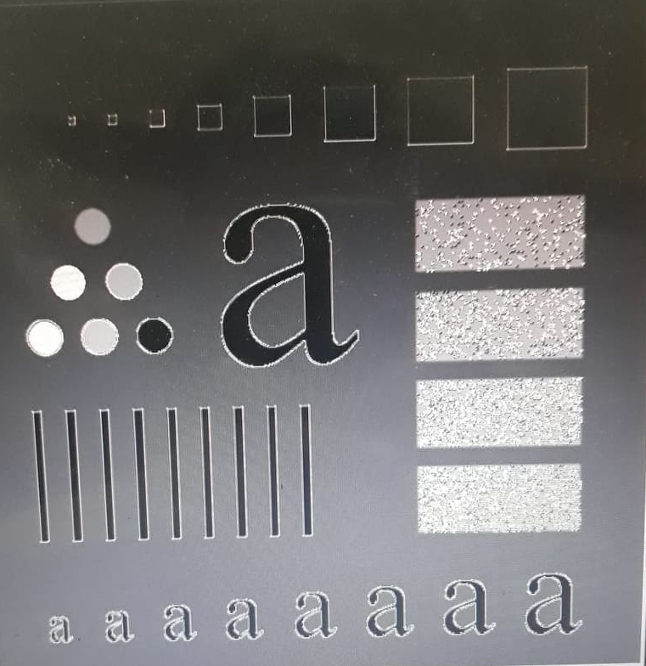

Apply the following Gaussian filter to the image given above. Here, the σ = 1.4. What impact do you think happen when the value of σ is increased? Don’t forget the normalizing factor while applying the given Gaussian filter.
Ans Sigma role is to maintain variation between mean position. When sigma increases, the variance among mean position also increases. When sigma is smaller, variance also becomes smaller.

Task #3: Un-sharp Masking
Code
#Include Necessary libraries
import numpy as np

from PIL import Image

#Open an Image and convert it into array
image_input= Image.open('unsharpmasking.tif')
imgA= np.asarray(image_input)
#Pad the imageArray with a constant value of dimension 1*1
imgpad= np.pad(imgA, (1, 1), 'constant')

#Initialize the mask with 1
fil= np.ones((3,3))
fil = fil/9
smoothing = np.zeros(imgA.shape, dtype = np.uint8)
#Traverse through each pixel and calculate average across each mask and replace this on existing pixel’s value
for row in range(len(imgpad)-2):
for col in range(len(imgpad[0])-2):
avg = 0
for r in range(len(fil)):
for c in range(len(fil[0])):
#Calculate the average by multiplying each mask filter with image secton
avg+= fil[r][c]*imgpad[row+r][col+c]
smoothing[row][col]= avg
#Perform Subtraction and Addition operation on image
smoothing = np.subtract(imgA, smooth)
smoothing = np.add(imgA, smooth)

smooth_image=Image.fromarray(smoothing)
smooth_image.show()
Screenshot
Original

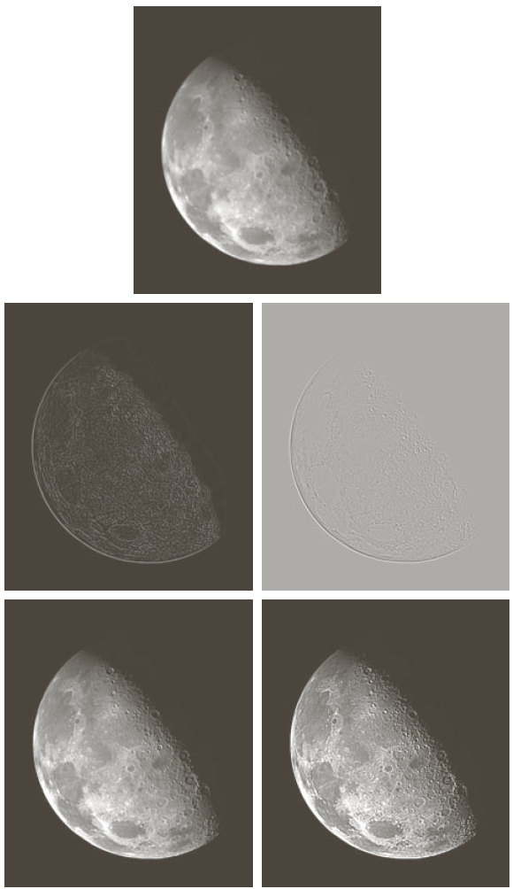

After Applying Unsharp Masking Filter

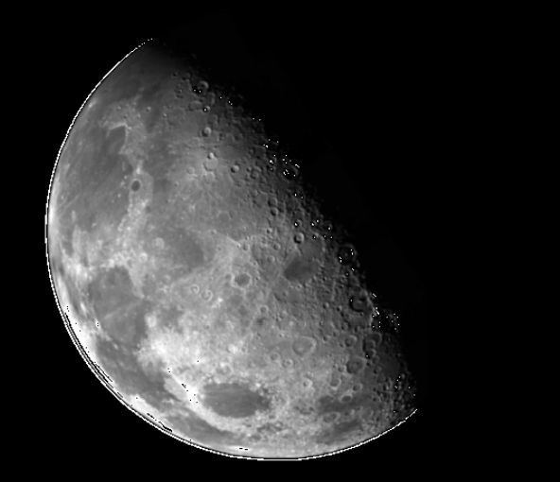

Does this enhance the image? Try with at least two different smoothing methods. How does that affect the results?
Ans: Yes, this enhances the image and increases the contrast level. One is Gaussian Smoothing that is performed earlier and other one is Unsharp Masking Filter. Gaussian filter creates more blurriness in the image as compared to unsharp masking Filter.

Task #4: Removal of Salt and Pepper noise

Code

import numpy as np
from PIL import Image
image= Image.open('saltandpaper.tif')
imgA= np.asarray(image)
imgpad= np.pad(imgA, (1, 1), 'constant')

fil= np.ones((3,3),dtype=np.uint8)

smooth = np.ones(imgA.shape, dtype = np.uint8)

for row in range(len(imgpad)-2):
for col in range(len(imgpad[0])-2):
med = 0
for r in range(len(fil)):
for c in range(len(fil[0])):
fil[r][c]*= imgpad[row+r][col+c]
med= np.median(np.sort(fil,axis=None))
smooth[row][col]= med
fil= np.ones((3,3),dtype=np.uint8)
smoothimage=Image.fromarray(smooth)
smoothimage.show()

Screenshot
Original

After Applying Filter
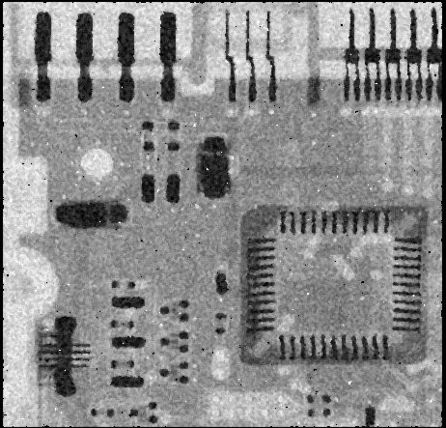

An image having salt and pepper noise is given below. Which filtering approach do you consider will suit best to remove the said noise? Apply the approach and show results
Ans. I used Median Filtering Technique that first sorts the Image Windows pixel’s values. After that a new mask which is initialized with one is used as a new window that contains sorted pixel values. Central position of that mask is the median. This method reduces the noise and pepper to some extent.

Task #5: Sharpening filters

Code
#Include Necessary Libraries
import numpy as np
import math
from PIL import Image
#Open an Image and convert it into grey scale
image= Image.open('im.jpg').convert('L')
#Make an array of Image pixels
imgA= np.asarray(image)
#Perform padding with a constant value
imgpad= np.pad(imgA, (1, 1), 'constant')
#Spatial Filter Horizontal Mask
sobely= np.array([[-1, -1, -1],
[0, 0, 0],
[1, 1, 1]],np.int8)
#Spatial Filter Vertical Mask
sobelx= np.array([[-1, 0, 1],
[-1, 0, 1],
[-1, 0, 1]],np.int8)
#Make an smooth named array having same size as of imageArray with values zero
smooth = np.zeros(imgA.shape, dtype = np.uint8)
#Traverse through each pixel and apply both Spatial Horizontal and Vertical Masks
for row in range(len(imgpad)-2):
for col in range(len(imgpad[0])-2):
sumx = 0
sumy = 0
for r in range(len(sobely)):
for c in range(len(sobely[0])):
sumy+= sobely[r][c]*imgpad[row+r][col+c]
sumx+= sobelx[r][c]*imgpad[row+r][col+c]
#Add both sum results of Horizontal and Vertical Masks and replace with original pixel’s value
smooth[row][col]= math.sqrt(math.pow(sumy,2)+math.pow(sumx,2))
smoothimage=Image.fromarray(smooth)
smoothimage.show()
Screenshot
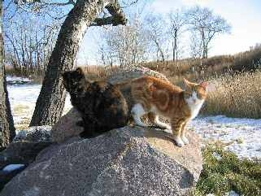
After Sharpening Filter
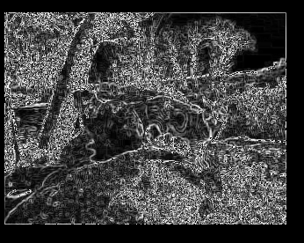
Conclusion
We performed filter in this lab. We applied smoothing filters, Average filters, Gaussian filters, sharpening filters to enhance the image and improve the contrast of the image. We compared two different approaches and find the better one between them.

